# [Oracle Data Platform — Finance Edition](http://127.0.0.1:5500/dev-ai-data-platform/workshops/sandbox/index.html?lab=introduction)

# Introduction

## About this Workshop

**Data isn't just an asset—it's the lifeblood of modern enterprises**.

Investing in the right platform isn't optional; it's the foundation for staying competitive and future-proofing business success.

In this hands-on workshop, you'll explore the full breadth of tools, services, and applications offered by **Oracle’s Data Platform**, and discover how they help organizations simplify the end-to-end data lifecycle — from ingestion and transformation to analysis and secure sharing.

Through a series of guided labs modeled on real-world tasks from a loan funding company, you'll experience how centralized data management, streamlined workflows, and intelligent analytics come together to unlock the value of enterprise data.

You will:

* **Gain Access to Data** from multiple sources to build a unified view, breaking down data silos and enabling comprehensive analysis.
* **Create and publish data products** for actionable insights, empowering other departments to be able to provide timely, data-driven decision-making feedback.
* **Securely share selected datasets** across departments, such as marketing, to support campaign planning while maintaining data governance and privacy.

By the end of this workshop, you'll understand how **Oracle’s Data Platform** provides a **scalable, future-ready foundation** for financial organizations seeking to:

✅ Increase agility

✅ Enhance collaboration

✅ Drive business success through data driven decision making

[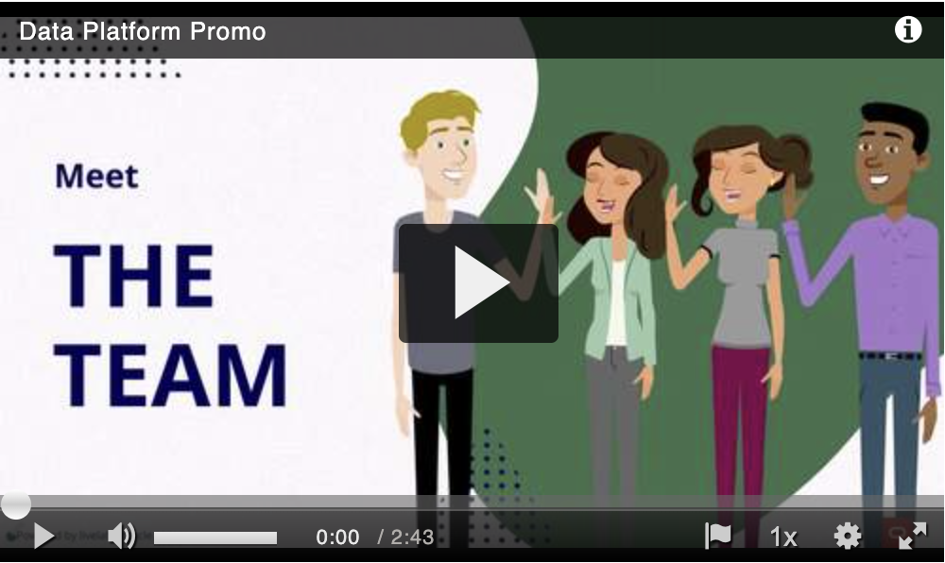](https://cfvod.kaltura.com/p/2171811/sp/217181100/thumbnail/entry_id/1_nnznmwsc/version/100011/width/500/height/297)

### **Objectives**

This workshop is divided into two key sections, each designed to provide a unique, hands-on experience with **Oracle’s Data Platform**:

### 1️⃣ **Demo Experience: Real-World Application Simulation**

Gain practical insight into how **data products** are used within a **Loan Management Application**.

In this section, you will:

Interact with the application from the perspective of different user personas — **Loan Officer** and, **Risk Management Officer**.

Follow user stories that demonstrate how having near real-time access to enterprise-wide data truly drives data-driven decisions for a competitive edge.

Understand how each role consumes data products and provides feedback that enhances **operational efficiency**, **risk assessment**, and **the efficiency of marketing campaigns**.

### 2️⃣ **Hands-On Data Engineering & Management Tasks**

Apply your skills through guided development tasks that simulate real-world data requests.

In this section, you will:

Receive a set of **enhancement requests** designed to support new requests for data access.

Perform **data discovery**, **data transformation**, and **data sharing** tasks to fulfil those requests.

Use **integrated data platform tools** to **manage data access**, **improve data quality**, and deliver **fit-for-purpose data products**.

### **Prerequisites**

This lab assumes you have:

* An Oracle account to submit your a LiveLabs Sandbox reservation.
* Basic knowledge of Oracle Database.

### **Key Terms**

#### **About Oracle Autonomous Database (ADB)**

Oracle Autonomous Database is a converged, multimodel platform that enables users to seamlessly work with both structured and unstructured data, including external sources — all within a single, unified environment. This integrated approach eliminates the need for multiple specialized databases, significantly simplifying data architecture and management. With support for all data types and workloads, Autonomous Database allows you to perform a wide range of analytics — from traditional SQL queries to machine learning and spatial analysis — across internal and external data sources. This unification empowers organizations to drive faster insights while reducing complexity and operational overhead.

#### **About Data Warehouse**

A data warehouse stores structured, cleaned, and preprocessed data for business intelligence and analytics. Primarily used for business intelligence (BI) and reporting, providing historical data analysis for trends and insights.

#### **About Data Lake**

A data lake is a substantial repository designed to store a wide variety of data, such as text, images, and videos, in their original and unstructured formats. Rather than categorizing or formatting the data up front, everything is gathered into one “pool.” This flexible approach allows analysts and researchers to determine how best to structure and interpret the data later on. However, maintaining clear governance and organization is crucial to prevent the data lake from becoming a disorganized “data swamp.”

#### **About Data Lakehouse**

Combines the flexibility of a data lake with the data management and querying capabilities of a data warehouse. This hybrid approach allows users to determine how best to structure and interpret the data, while still benefiting from higher reliability and query efficiency. It is aimed at facilitating machine learning, business intelligence, and predictive analytics.

#### **About Data Platform**

A data platform is a technology solution that enables the collection, storage, cleaning, transformation, analysis and governance of data. Data platforms can include both hardware and software components. They make it easier for organizations to use their data to improve decision making and operations. Data platforms are increasingly more popular with the need for a centralized solution to meet today’s AI needs. AI applications and solutions need access to data in real time to enable better solutions and greater innovation.

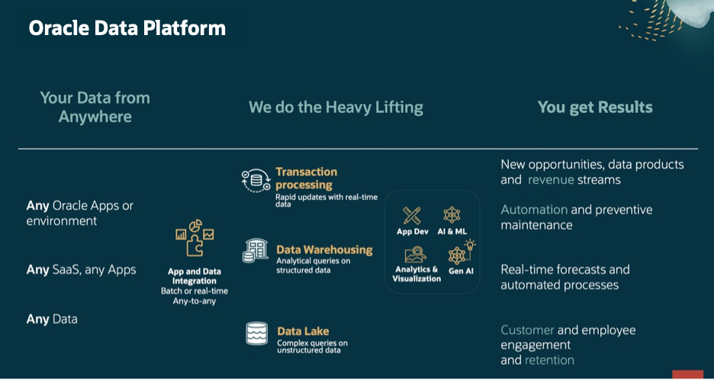

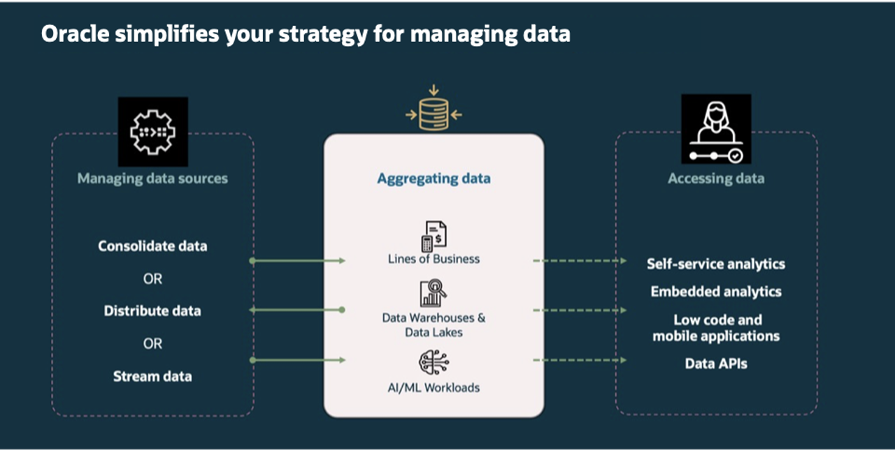

#### **About Data Product**

A data product is a curated, reusable data asset designed to address a specific business need or deliver actionable insights. It transforms raw data into trusted, consumable information that can be easily accessed and used across various applications, teams, and use cases — both internally and externally. Data products are built with quality, context, and usability in mind. They include essential elements such as metadata, data lineage, and governance policies to ensure trust, transparency, and consistency. By treating data as a product, organizations can scale data sharing, accelerate innovation, and enable data-driven decision-making across the enterprise.

#### **About Data Catalog**

Oracle Cloud Infrastructure (OCI) Data Catalog is a fully managed, self-service solution for data discovery, governance, and metadata management across your enterprise data landscape. It provides a centralized, collaborative environment where users can manage technical, business, and operational metadata in one place. With Data Catalog, you can collect, organize, search, access, enrich, and activate metadata—making it easier to understand your data assets, ensure governance, and drive greater data utilization across your organization.

Collapse All Tasks

### Learn More

[The Catalog Tool](https://docs.oracle.com/en/cloud/paas/autonomous-database/serverless/adbsb/catalog-entities.html)

[Autonomous Database](https://docs.oracle.com/en/cloud/paas/autonomous-database/index.html)

### Acknowledgements

**Authors** - Eddie Ambler, Otis Barr, Matt Kowalik, Ramona Magadan

**Contributors** - Francis Regalado

**Last Updated By/Date** - 04/21/2025

# Get started - Login to the LiveLabs Sandbox Environment

Estimated Lab Time: 5 minutes

## **Introduction**

Welcome to LiveLabs. You have successfully created a LiveLabs Sandbox environment.

In this lab, we will show you where you can find the login information and how to log in to the LiveLabs Sandbox.

## **Objectives**

* Login to LiveLabs Sandbox
* Find your LiveLabs Sandbox reservations

## Task 1: View Login Information and login to your LiveLabs Sandbox

1. Right above the workshop instructions you can find two information:

a. **View Login Info:** You can find credentials and other information to access the LiveLabs Sandbox

b. **Time Remaining:** This shows you the remaining time before your access to the LiveLabs Sandbox expires. Please note: You may be able to extend the reservation time.

View Login Info

1. Click **View Login Info** to see detailed reservation information. Click the **Start the Demo** link.

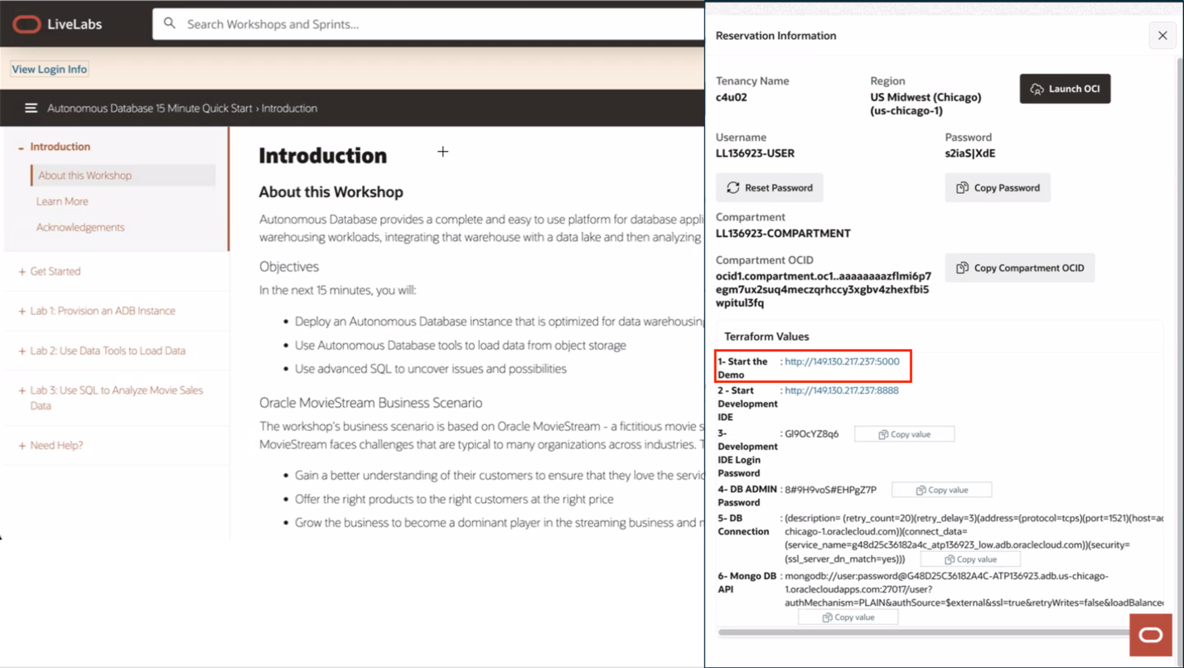

1. Congratulations! You are now connected to the demo environment. You can now execute the different tasks and steps for the selected LiveLabs workshop.

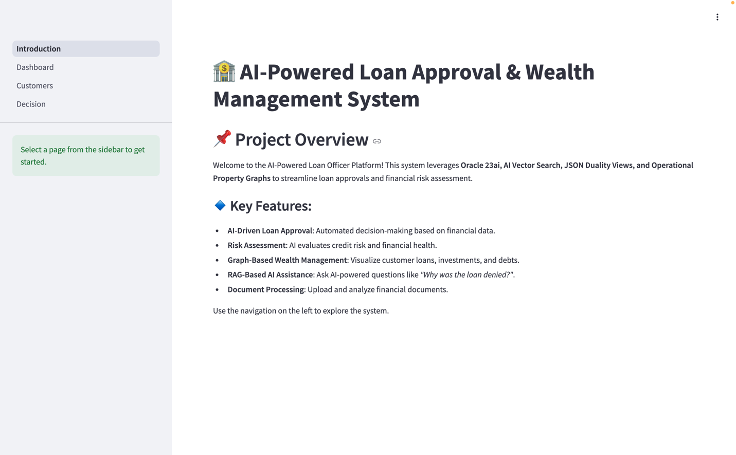

## Task 2: Find your LiveLabs Sandbox reservations

1. If you close your browser, and you want to launch your workshop again, open [livelabs.oracle.com](https://livelabs.oracle.com/), login using your Oracle account, and click on **My Reservations**. You can find here a complete history of all LiveLabs workshops you signed up for. Click on **Launch Workshop** to start a workshop with an existing LiveLabs Sandbox environment.

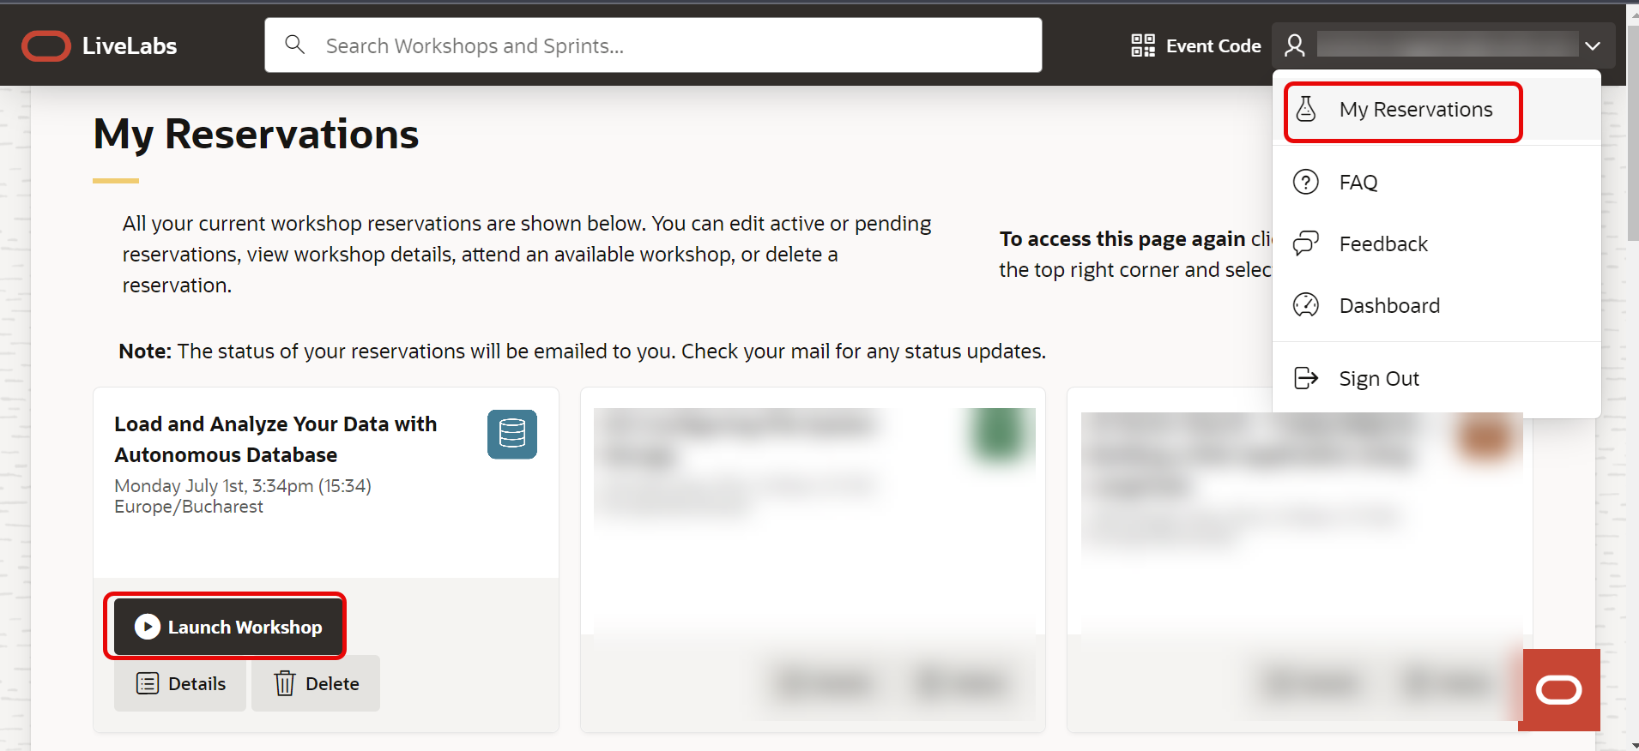

You may now **proceed to the next lab**.

## Acknowledgements

* **Created By/Date** -
* **Contributor** -
* **Last Updated By/Date** - 04/21/2025

# 🏗️ Build your Data Pipeline: Load & Transform Data (optional lab)

Estimated Lab Time: 45 minutes

## Introduction

In this lab, you’ll practice importing data from Oracle Object Storage and preparing it for analysis in various formats. You’ll learn how to load JSON data into the Oracle Autonomous Database and prepare it for use.

## Task 1: Discover Data from Object Storage.

In this task, you’ll work with a JSON-formatted file stored in your Oracle Object Storage bucket.

Here’s what you’ll do:

📥 **Access the Object Storage Bucket**

1. Access the Object Storage Bucket

On the left rail, select Catalog  to locate the file containing loan funding data in your Object Storage bucket.

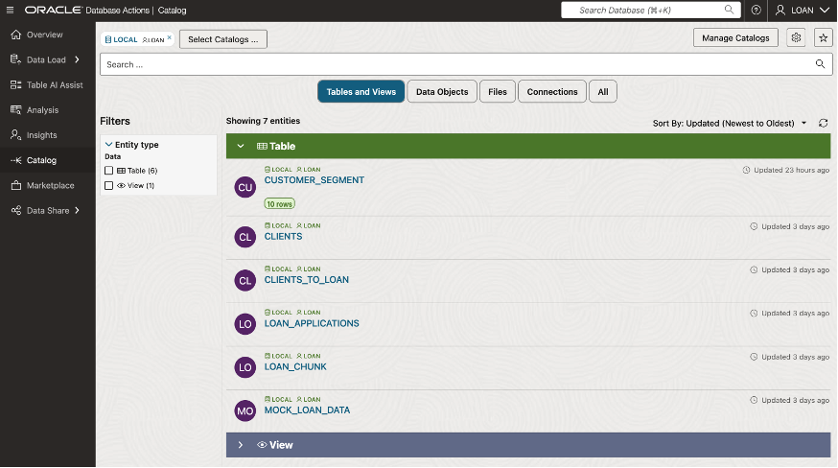

1. Select Data Objects to display the available database objects and the listing of the files available in our object storage

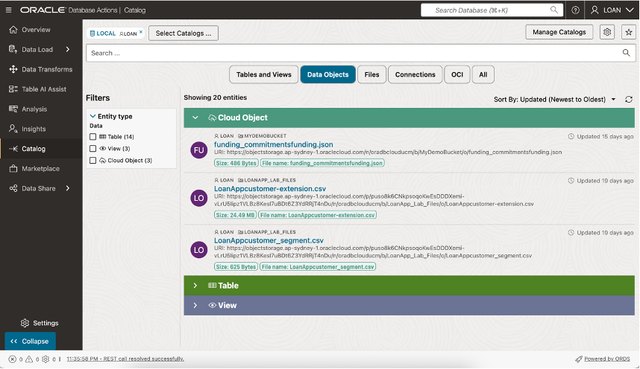

1. Hover over file name to see data preview option and Click the Preview Icon on the far right, to display data preview.

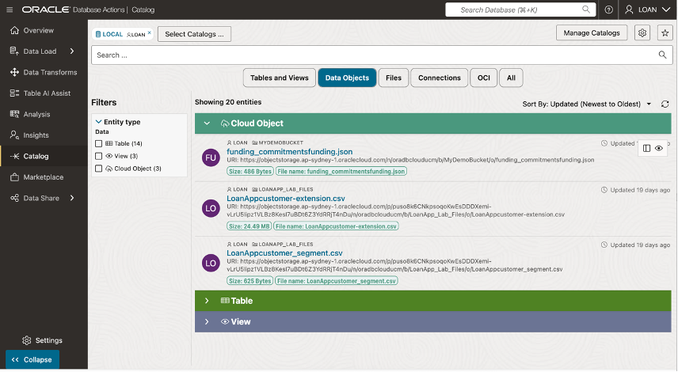

1. This displays the contents of the file being previewed without needing to first load it into the database.

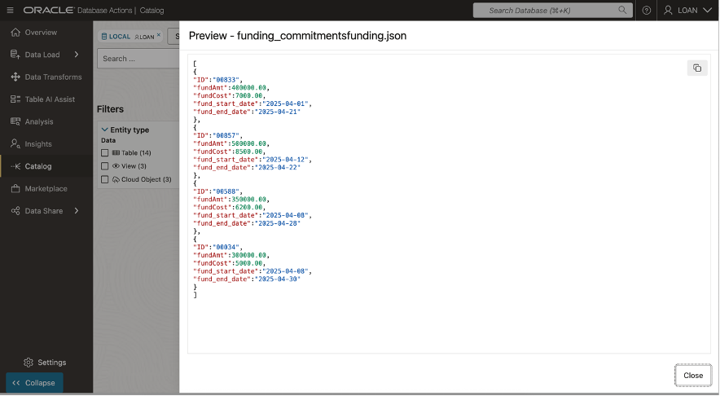

Click on Close button to return to Data Catalog listings.

## Task 2: Load Data from Object Storage.

1. Hover over file name to see data preview option and Click the View Details icon on the far right, to display file details.



1. Select the Load to Table button and the Load Data page will appear

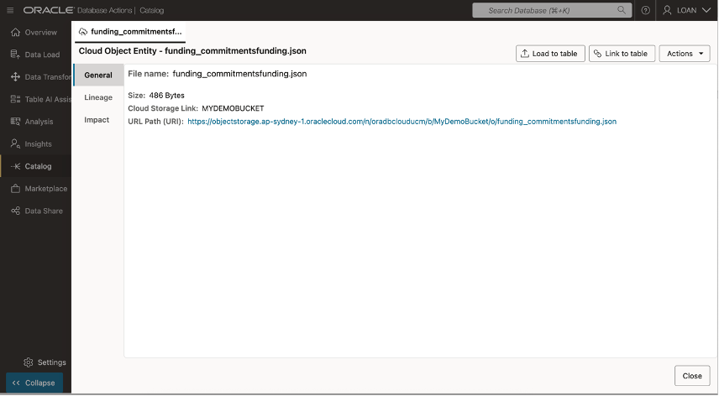

1. Select the Start button and the Load Data page will appear.

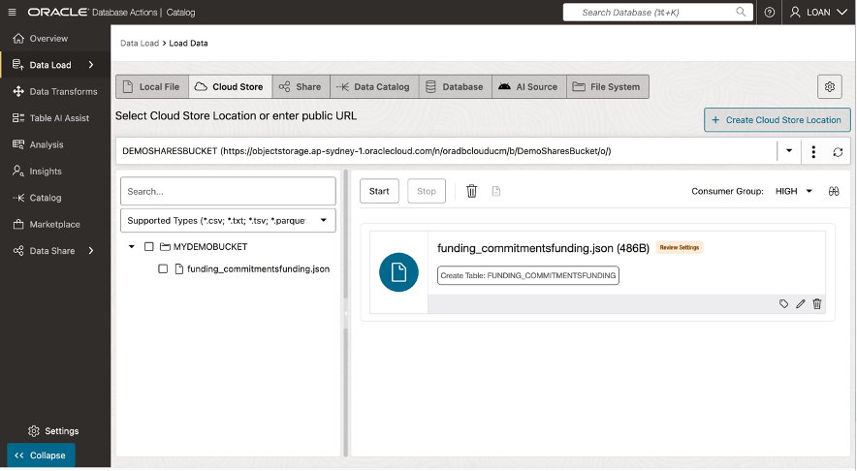

1. Select the Start button to submit data load job.

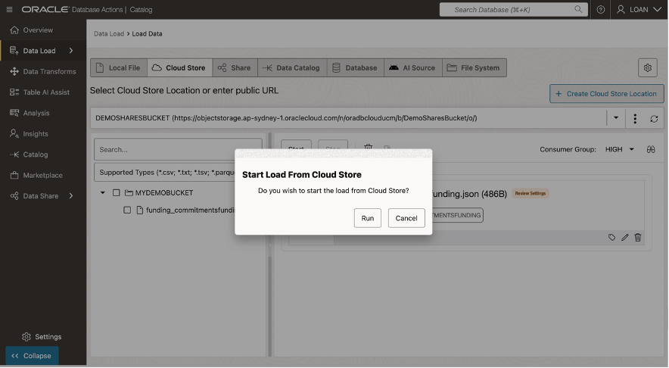

1. ~~Select the Start button to submit data load job.~~

At the end of this task, you’ll have successfully imported and validated JSON data, making it available for use within the Oracle Autonomous Database.

## Task 3: Combine Data from Object Storage

1. Enter the Bucket Information properties window. Verify that Emit Object Events”is enabled.

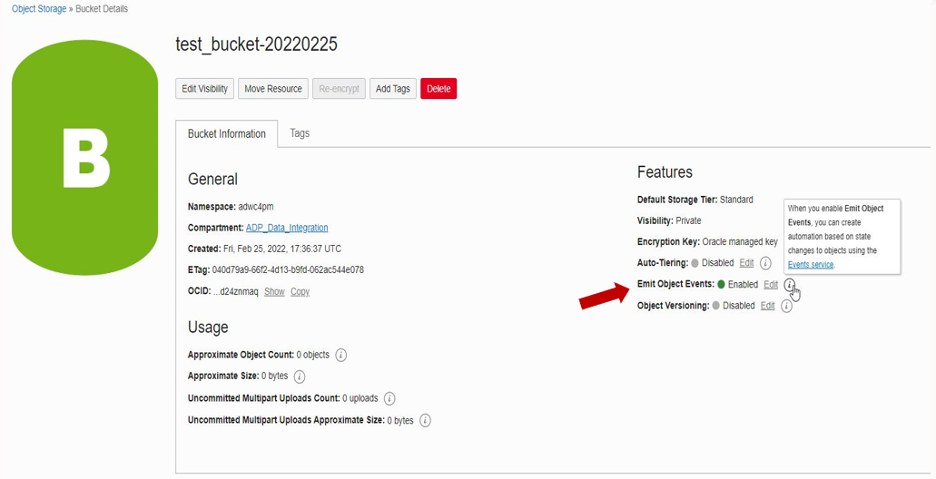

### Autonomous Database: Live Feed setup

Step 3: In the Autonomous Database’s Database Actions menu, go to Data Load and add Cloud Storage using the URL for the Object Store bucket. Select the appropriate authentication mechanism.

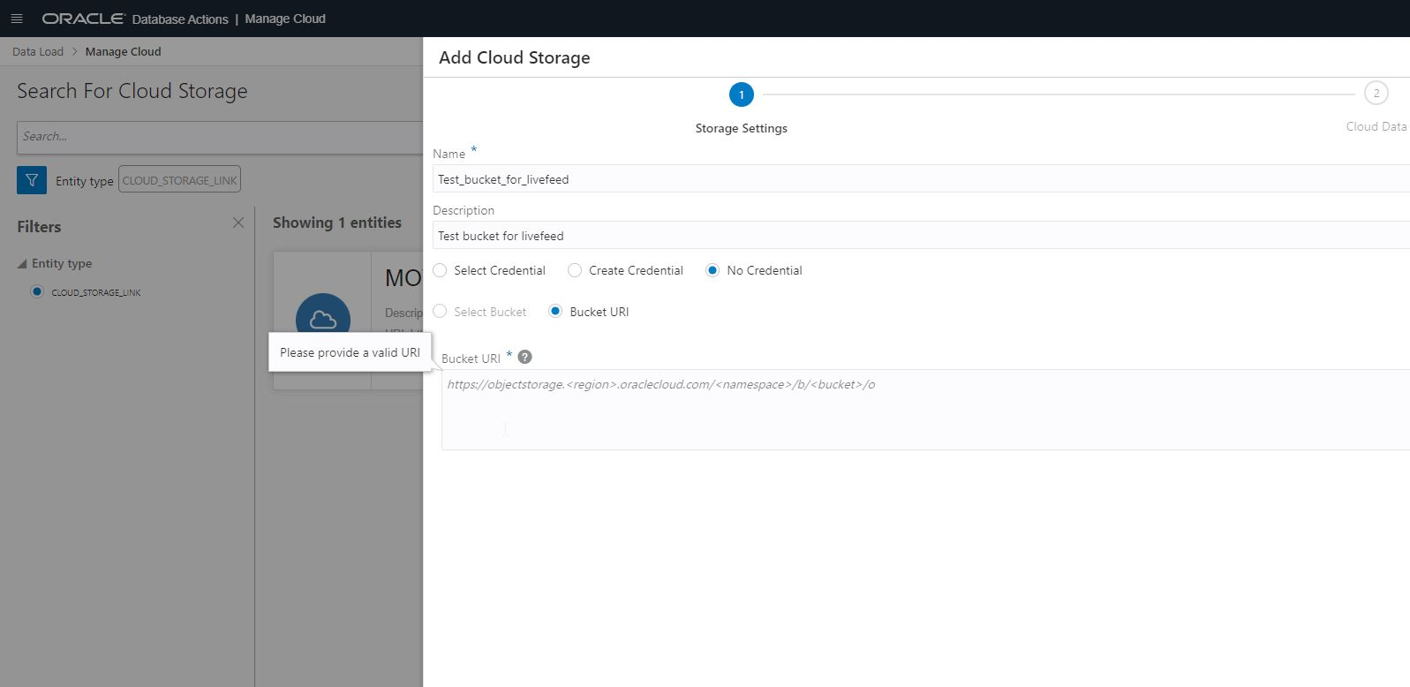

In this task, you’ll work with a JSON-formatted file stored in your Oracle Object Storage bucket.

Here’s what you’ll do:

📥 **Create a Live Data Feed**

#### Navigate to Data Load: Feed Data

On the left rail, select Catalog to locate the file containing loan funding data in your Object Storage bucket.

#### Create a Live Data Feed with the following properties:

|  |  |
| --- | --- |
| Live Table Feed Name: | <User given name> |
| Target Table Name: | <table to be loaded in ADB> |
| Cloud Storage: | <previously added cloud storage URL> |
| Enable for Notification: | Checked |
| Scheduled: | Unchecked |

(Note: We are enabling it only for notification. It means live feed will kick off anytime an object is loaded into the bucket. This is enabled by the notification mechanism that we will setup for the object store bucket in rest of the steps. It is possible that both time-based scheduled feed and notification-based feed are enabled but in this case we are only interested in notification based feed

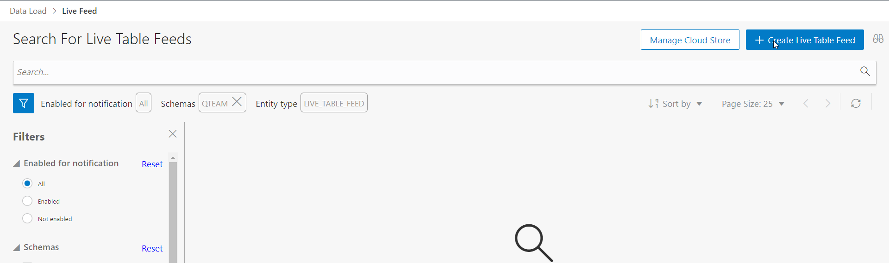

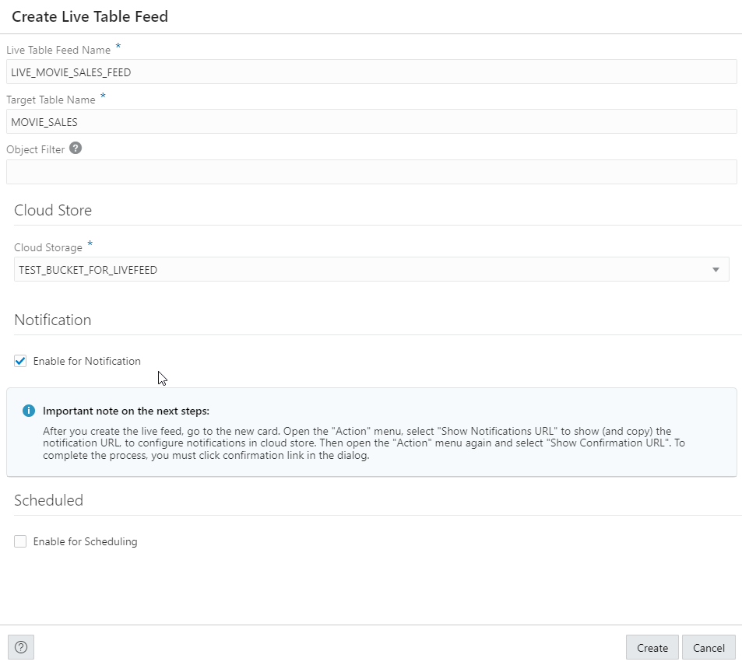

#### Copy the notification URL for the live table feed, so that we can use it to link up with the OCI event generation mechanism. The live feed is triggered using the URL. (refer to the diagram in the beginning of this blog to see the entire flow).

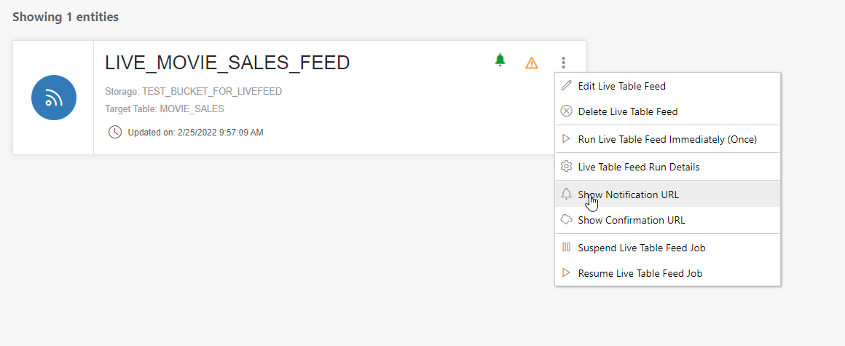

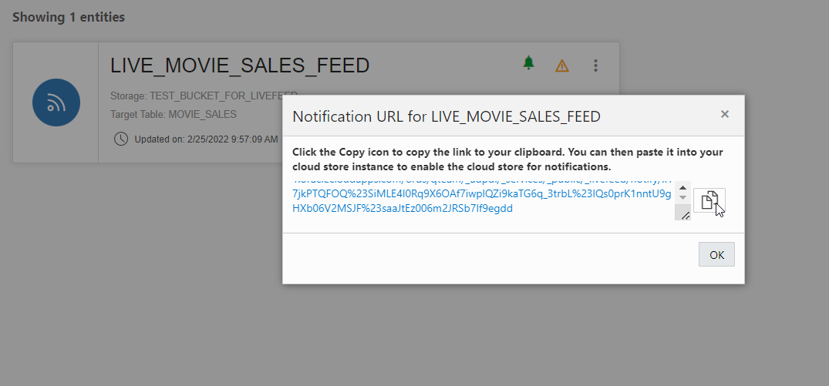

### OCI: Event generation, notification, and subscription setup

#### In OCI’s Notification menu, create a topic. Give it a user-friendly name

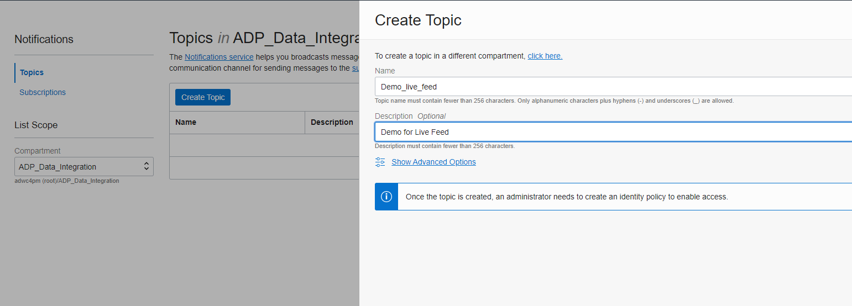

#### In the Events menu, create a Rule. Fill in the following sections for the rule:

|  |  |
| --- | --- |
| Display Name: | <user given name for the rule> |
| Rule Condition section: |  |
| Condition: | Event Type |
| Service Name: | Object Store |
| Event Type: | Object Create |
| Actions: |  |
| Action Type: | Notification |
| Notification Compartment | <your compartment> |
| Topic: | <earlier created Topic> |

Note: Rules in OCI support rich capabilities for tracking specific events, including update of existing objects. The above configuration provides a simple way to trigger notifications when new files are created in the bucket.

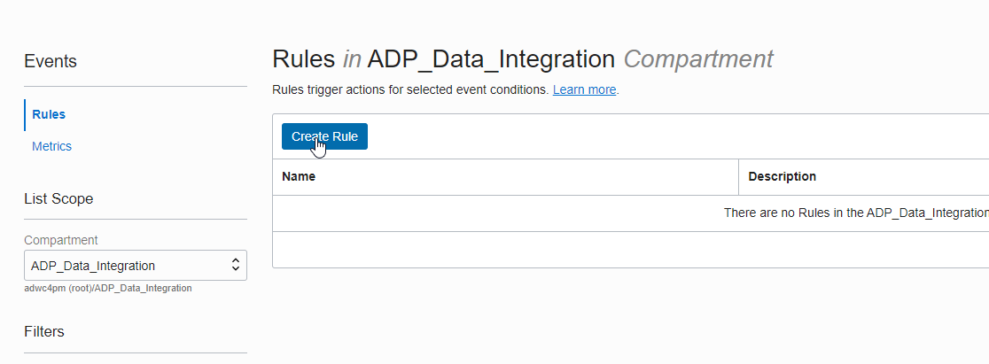

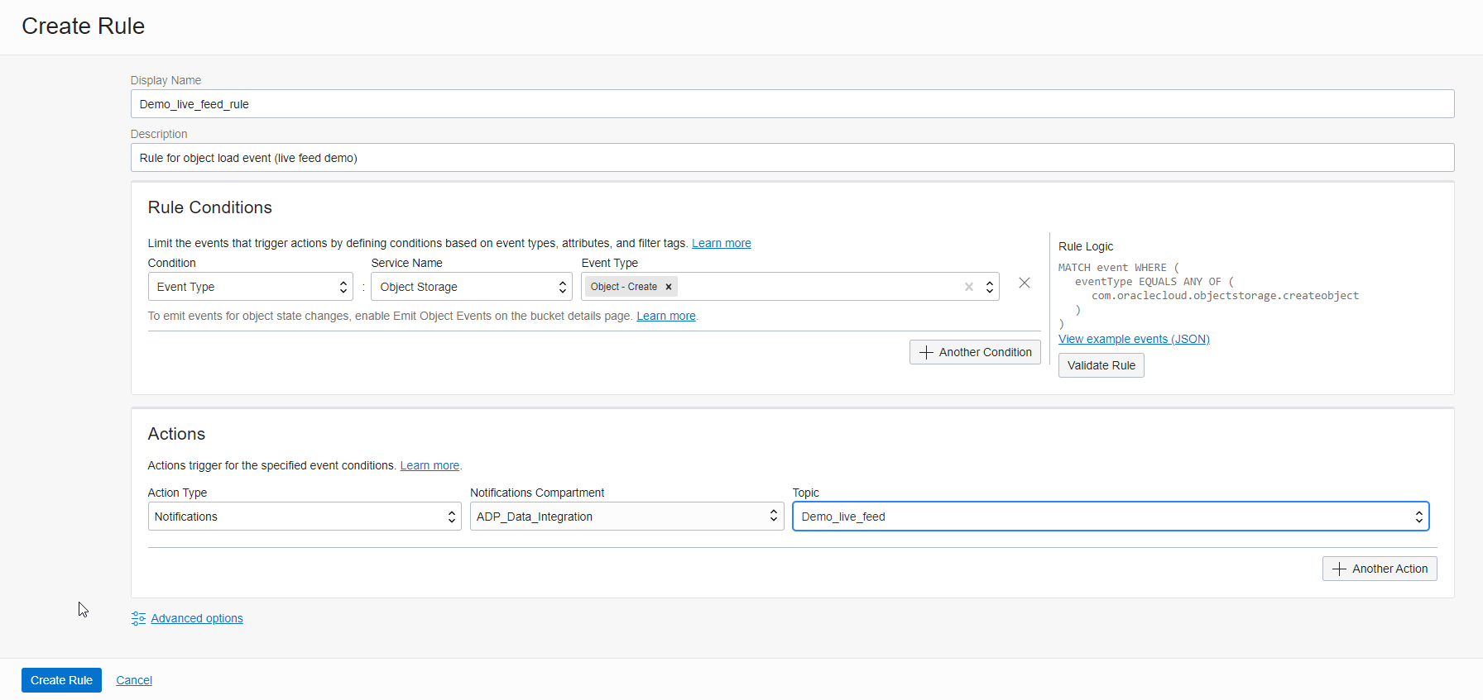

#### In the Notification menu, create a subscription with the following properties:

|  |  |
| --- | --- |
| Subscription Topic: | <the name of the Topic you just created> |
| Protocol: | HTTPS (Custom URL) |
| URL: | <the Live Table Feed URL created earlier in the Autonomous Database setup section> |

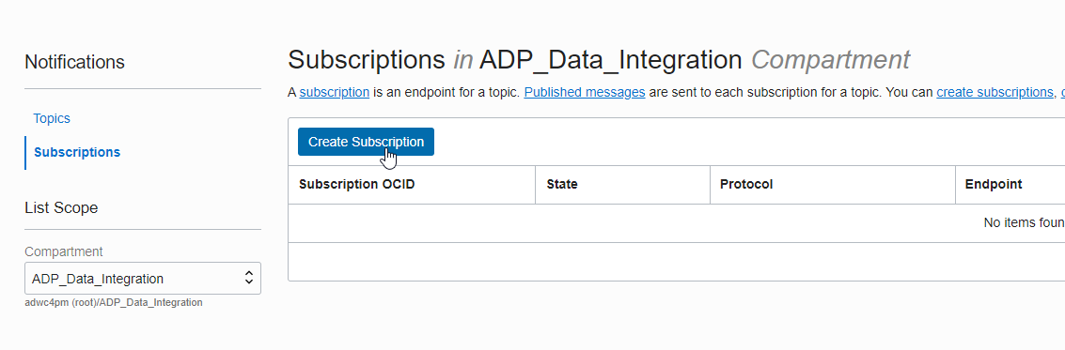

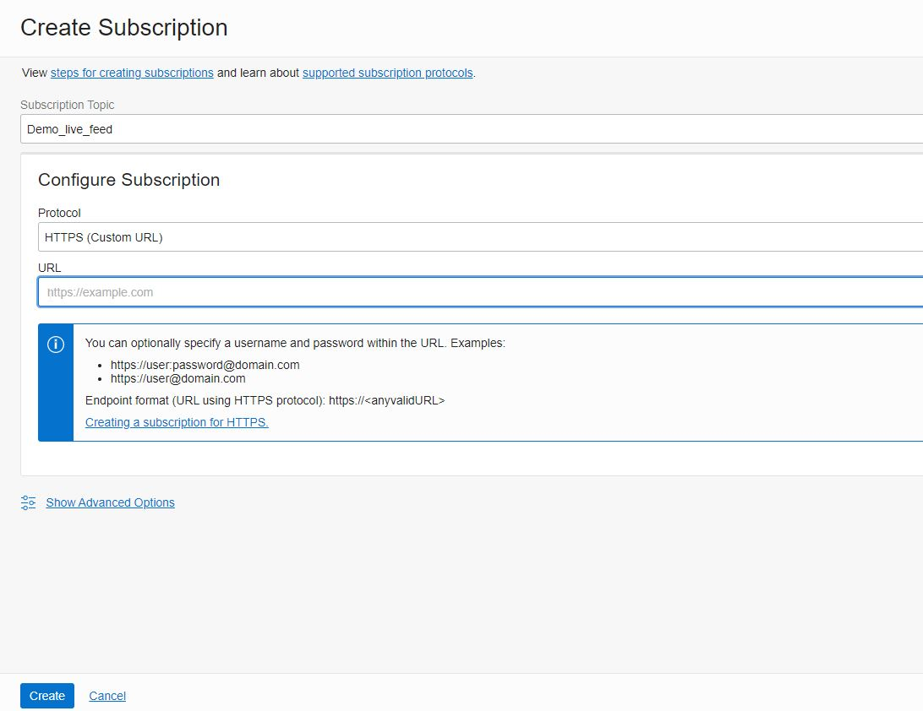

Now everything is set up, and the Live Table Feed is waiting for objects to be created in the bucket. The subscription will show in pending status immediately after creation. It takes couple of minutes for it to turn into “Active”.

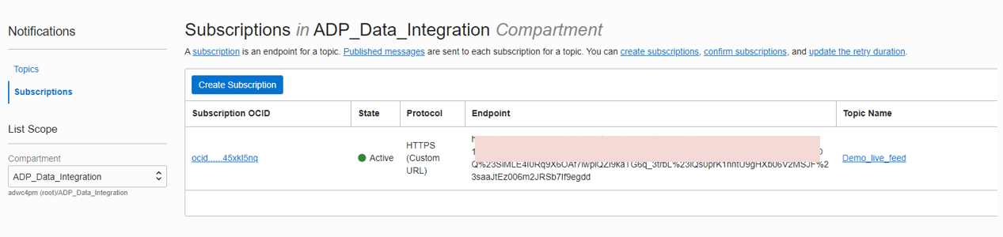

Now will try loading a file in the bucket. This will notification event.

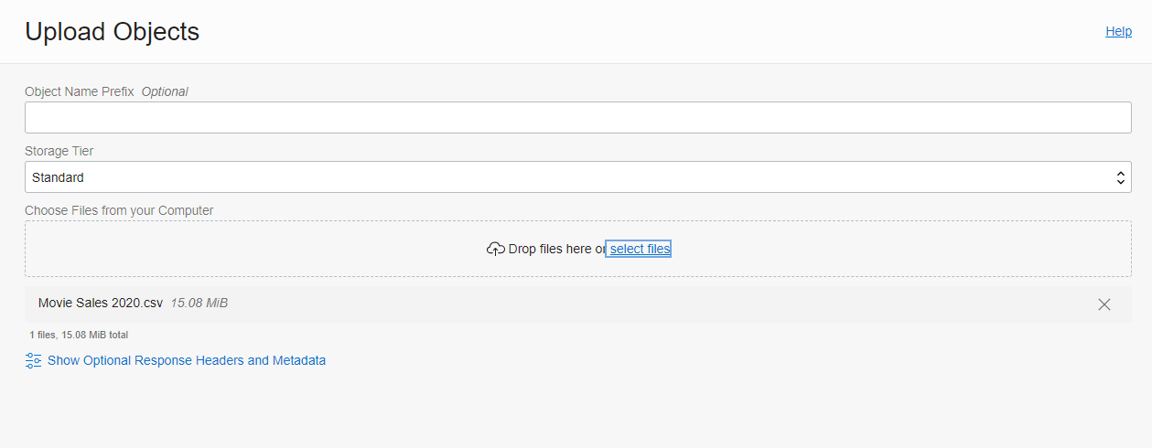

It may take a few minutes for the event to be generated and the Live Table Feed to start loading the data to the target table. See below for monitoring the run details.

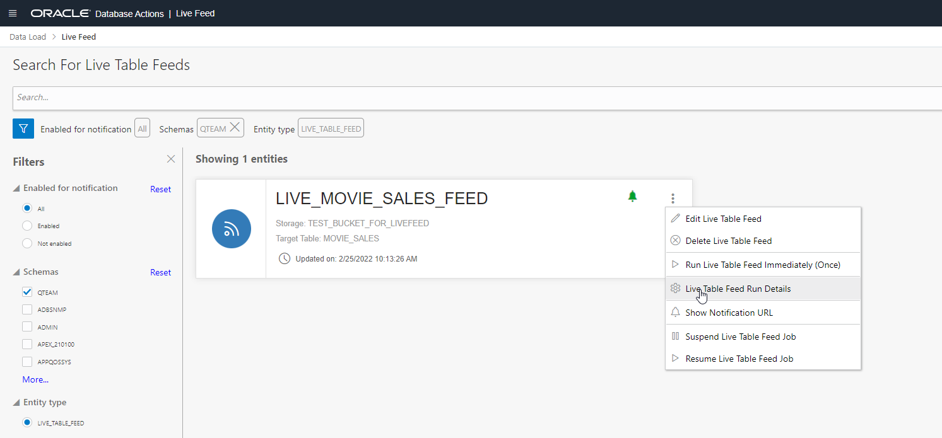

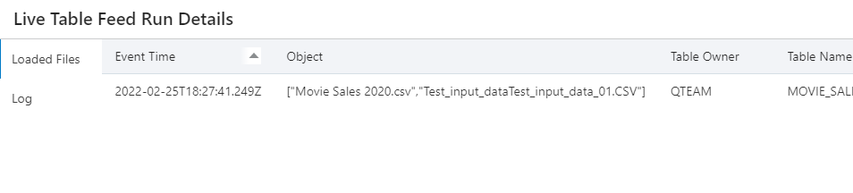

You can see that the object Movie Sales 2020.csv has been loaded to the target table MOVIE_SALES. Anytime a new version of movie sales data file is uploaded to the object store, the data will be loaded into MOVIE_SALES table. You may want to refer to the diagram in the beginning of this blog to see the entire chain of events that make it happen.

Final Comment: It is important to note that although we have set up this Live Feed from Oracle Object Store, the same mechanism for subscribing to events can be setup for other Object Stores, such as Amazon Web Services S3, or Azure Data Storage. All you need is the Live Table Feed URL – this can be linked to the event notification mechanisms in most other object storage platforms.

🔄 **Transform JSON Data Using ELT**

* Extract meaningful information from **nested JSON structures** using SQL/JSON functions like JSON_TABLE or JSON_VALUE.

Clean and reformat the data as needed:

* **Normalize nested structures** into relational tables.
* **Convert inconsistent formats** (e.g., dates or currency) into standard formats.
* Store **transformed data** in a new table optimized for querying.

🔗 **Join Loan Offers with Other Data**

* Combine loan offer data with other tables in your database using **SQL joins**.

For example:

* Link loan offers with **customer demographics** or **property details**.
* Run advanced queries to gain insights:
* Identify **trends in loan offers** by region or applicant type.
* Analyze **loan approval rates** based on interest rates or terms.

✅ **Validate and Test Queries**

* Verify that transformations were applied correctly by running **test queries** on the transformed data.
* Ensure that all **key fields are accessible** and properly formatted for analysis.

By completing this task, you’ll understand how to handle complex JSON files, transform them using ELT processes, and integrate them with other datasets for deeper insights.

**Note:** <SCREENSHOTS!>

## Learn More

* [The Catalog Tool](https://docs.oracle.com/en/cloud/paas/autonomous-database/serverless/adbsb/catalog-entities.html)
* [Autonomous Database](https://docs.oracle.com/en/cloud/paas/autonomous-database/index.html)

## Acknowledgements

* **Authors** - Eddie Ambler, Otis Barr, Matt Kowalik
* **Contributors** - Francis Regalado, Ramona Magadan
* **Last Updated By/Date** – TBC

Copyright (C) Oracle Corporation.